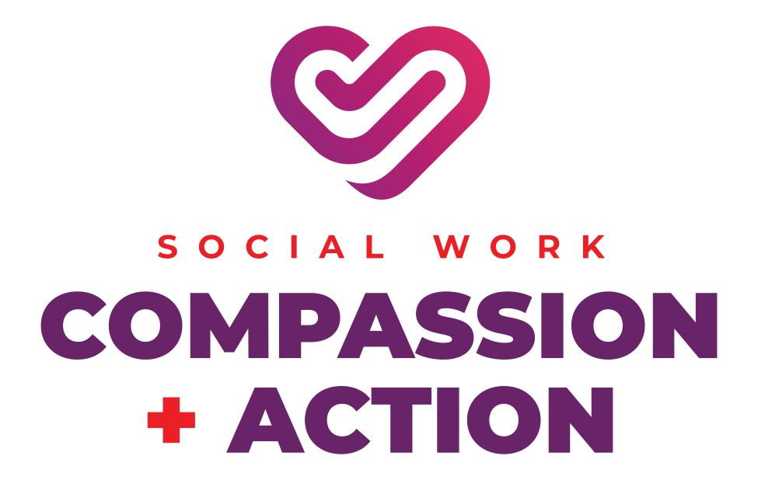

Let Your Voice Be Heard! Submit Your Video to be Considered for the 2025 Student Convocation Speaker

If you are interested in being the 2025 Student Convocation Speaker, please submit a 5-minute video file of you delivering your speech to Dean Henriette Taylor at HTaylor@ssw.umaryland.edu by March 31, 2025, at 5:00 pm to be considered.

Videotaped speeches will be reviewed by the student convocation planning committee, to decide who is chosen for this honor. The speech must directly relate to the 2025 NASW Theme; Social Work Compassion + Action: https://www.socialworkers.org/News/Social-Work-Month.

However, you decide to approach the theme is up to your creative discretion! All May and July 2025 graduates are eligible to apply. You can record your speech using any video platform including VoiceThread:
https://sites.google.com/site/sswideateam/students/tools-technologies/voicethread-for-students

If you have additional questions, please contact Dean Henriette Taylor.

